The Power of Significant Learning during Course Development
June 28, 2021
Vicki Caruana PhD
In the certificate programs I manage, we are engaged in the tumultuous whirlwind of complete curriculum overhaul. At times it does appear as if pieces of the puzzle are swirling in the air above our heads like debris caught up in the funnel of a tornado. Instead of worrying that this is all out of our control, I choose to view the process of putting together a meaningful curriculum for our learners as something a little more elegant.
Employing the process of backward design is one crucial component to this endeavor. The other is significant learning. Significant learning (Fink, 2003) presumes that we first desire that what our learners gain is significant, and not insignificant. As current experts in our fields, we are in a unique position to determine what is considered as significant learning in our disciplines. For our purposes, significant learning is not only determined by the faculty, it is determined as well by our accreditors and other agencies within our discipline to which we are accountable. The professionalization of a field depends on a common agreement of what is significant learning.

Significant learning is more than just deciding what types of learning are significant. We must frame this learning in a taxonomy that offers opportunity to reflect on deeper meaning. Fink (2003) proposed a taxonomy of significant learning that honors Bloom’s taxonomy, yet takes it to a higher level. As an educator in a public institution, I see a clear connection to our mission and vision in this taxonomy (see Figure 1).
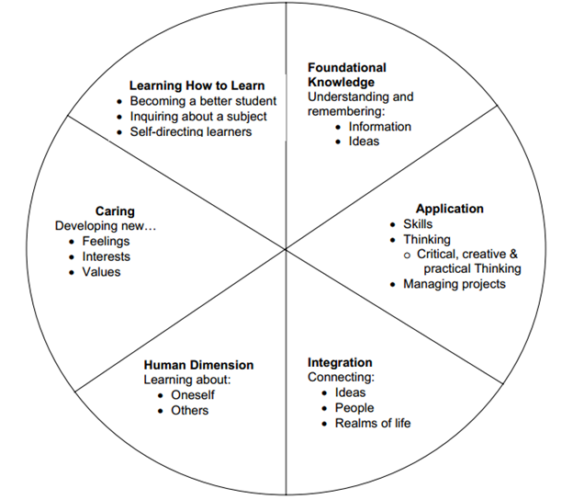Figure 1
If we are to be intentional about the mission, in particular one that “. . . provides online, classroom-based and customized programs of study that are responsive to the needs of our students and our city, focusing on fields as well as forms of teaching, learning, and scholarship that highlight innovation, personal and social progress, and opportunities for careers and services,” then this must be part of our program and course development from the ground up. The taxonomy of significant learning offers an entry point to this type of curricular development.
Fink (2003) attributes special values to each of the categories of the taxonomy. I offer, as well, the added value of the core values of our institution.

Foundational knowledge
- Special value: Foundational knowledge provides the basic understanding that is necessary for other kinds of learning
- Added core value: Quality

Application
- Special value: Application learning allows other kinds of learning to become useful
- Added core value: Opportunities for careers and service

Integration
- Special value: The act of making new connections gives learners a new form of power, especially intellectual power
- Added core value: Personal and social progress

Human dimension
- Special value: This kind of learning informs students about the human significance of what they are learning
- Added core value: Inclusion, equity, and diversity

Caring
- Special value: When students care about something, they then have the energy they need for learning more about it and making it a part of their lives. Without the energy for learning, nothing significant happens
- Added core value: Personalization

Learning how to learn:
- Special value: This kind of learning enables students to continue learning in the future and to do so with greater effectiveness
- Added core value: Personal and social progress

In Fink’s A Self Directed Guide to Designing Courses for Significant Learning (2004), the reality that many faculty in institutions of higher education have little, if any, experience in curriculum development is acknowledged and addressed. This explicit guide, based on a popular professional development workshop, offers those engaged in curriculum development and course design a structured way to meet their goals for learners and create both significant and meaningful learning experiences.

If our goals for learners include more than the dissemination of information, but the life and career altering transformation, we must plan for this from the very beginning and the very first learning encounter. Part of creating a transformative learning process includes incorporating meaningful and continual assessment and feedback. Significant learning focuses on learner-centered course development, not content-centered course development. As such, feedback from learners is crucial. Two types of assessment and feedback enhance the quality of learning:
- Forward-looking assessment: Incorporates exercises, questions, and/or problems that create a real-life context for a given issue, problem, or decision to be addressed

- Self-assessment: Creates opportunities for learners to assess their own performance
Coupled with active learning, learner-centered course development is the vehicle for promoting significant learning that is transformational. If you or your colleagues are engaged in any type of course development, consider the tenets of significant learning on which to build.

Vicki Caruana is an academic program manager and professor at the School of Professional Studies in the City University of New York. Caruana’s PhD is in curriculum and instruction, and she has mentored faculty at several institutions to create meaningful learning experiences in both traditional and online contexts. She has authored more than 30 books for both teachers and parents, including the best-selling Apples & Chalkdust: Inspirational Stories and Encouragement for Teachers.

References
Fink, L.D. (2003). Creating Significant Learning Experiences: An Integrated Approach to Designing College Courses. San Francisco: Jossey-Bass.

Fink, L. D. (2004). A self-directed guide to designing courses for significant learning. Retrieved from http://trc.virginia.edu/Workshops/2004/Fink_Designing_Courses_2004.pdf

