Moving from Zoom to In-Person Teaching
Todd Zakrajsek
International Teaching Learning Cooperative

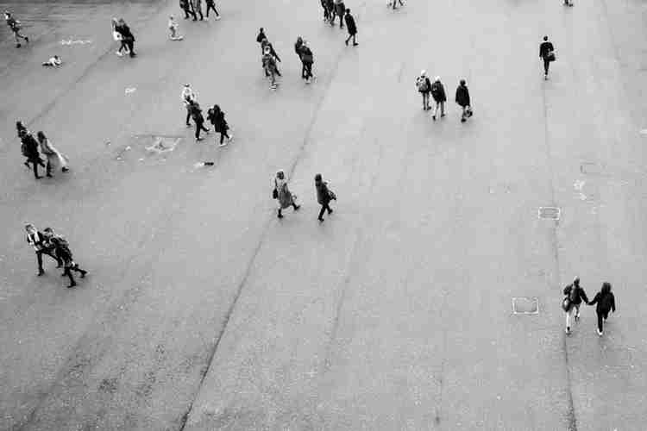
In the spring of 2020, COVID jolted education into a new world of technology applications. This new form of teaching required sitting for hours on end as we taught to tiny images of our students. I learned a LOT about Zoom, WebEx, and MS Team Meeting in a few short weeks. In contrast, it took a while to build up my stamina for online meetings. At first, I had trouble staying seated for hours on end. It simply wasn't what I was used to doing. Not only did I have nervous energy and needed to stand up and move around periodically, but my back was also hurting for long periods of the day.

Then I started to "toughen up" the group of muscles needed to sit in front of a computer for eight to ten hours a day. It took an embarrassingly long time to figure out that jumping from one online meeting to the next didn't allow me time to eat, stretch, or even use the restroom. Before COVID, breaks between meetings were natural. Meetings were spaced to account for walking to a different building, or at least another room within the same building, allowing stops at a restroom or drinking fountain as needed. With Zoom, that was gone. A meeting ends at 10:00, click the "leave" button, and then 30 seconds later, you could be in the next meeting room. I recently started to schedule short breaks between web meetings, if even for only 15 minutes. Little by little, I developed my "Zoom muscle groups," created cognitive breaks, and incorporated stretch breaks into my work schedule. After a bit of time, I became fluent in online working.

Just as I became proficient with breakout rooms, polling, monitoring chats, and figuring out when I would ask students to turn on their cameras, it is ending. Don't get me wrong; I am happy to be headed back to campus. I am not sure I am ready. Yes, I know some of you went back to onsite teaching last year, but many of us have been sitting in front of desktop computers or laptops for 15 months or longer. Now is the time to construct a plan for returning to teaching onsite. For many of us, there is considerable work to do. As I began preparing for Fall, I recognized additional items that require attention for my success. Below I offer several suggestions for your consideration.
Clothing. I have been wearing pajama bottoms and sweatpants for a long time now. Button-down shirts and ties; those I have kept in the clothing rotation throughout the webinar months. Now it is time to locate the rest of my wardrobe. I admit it took me a few minutes to find my dress shoes. I am totally serious when I tell you they had a very thick coat of dust on them. Shoes now dusted, shined, and ready to go. Check.
It was also surprising that my dress slacks do not fit me precisely in the same way I remember them fitting before COVID. I know I have not worn them for over a year, but I recall them fitting differently. I have not yet bought new dress slacks, but I will be shopping soon. While I am there, I will likely purchase a new belt and socks.

Standing Stamina. Just like the time it took me to develop the muscle group needed to sit for hours on end, it recently occurred to me that I spent a LOT of hours on my feet when teaching onsite. Teaching a class or workshop for a few hours, walking to another building, and then stopping to chat with someone in the hall. Followed by another workshop or class in the afternoon. Sometimes I would walk quickly to a nearby restaurant for a speedy lunch that, at times, I ate while walking back to my office because I spent much of my time standing in line. I doubt that I am ready to stand, pace, and walk for hours on end each day. I recently started walking more, partly for the exercise and partly to feel better about the slacks and belt mentioned previously, but mostly to prepare myself to be on my feet for long periods. I suggest you consider ramping up to whatever physiological challenges will face you in just a few short months.

Teaching Skills. Let's face it, Zoom teaching is very different than in-person teaching. I miss being in a classroom full of students. I miss the energy created when dozens, or hundreds, of humans in the same space debate an issue. That said, I am not going back to how I used to teach. There are options now that I didn't have or didn't know about previously. One-to-one conversations with my students are valuable. Now I can have five or six quick check-ins with students over Zoom. Likewise, review sessions, small group discussions, and student presentations can occur over Zoom and be recorded for those who can't make the time selected. This also saves students time and money (Zakrajsek, 2020). They don't have to commute to campus, fight to find a parking spot, or hire a babysitter. In addition, students with learning and physical challenges have often found web-based education more accommodating than onsite courses (Puang, 2021). Integrating new strategies learned while pandemic teaching with traditional onsite teaching will take time. Best to start soon so that you are ready when Fall arrives.

Emotional Well Being. One thing we have already seen at institutions where in-person classes are resumed is that everyone is stressed. Student, and faculty, mental health is going to be an issue. Living through a pandemic is a huge deal and puts an enormous amount of stress on everyone. Mostly, just be ready for many mental health challenges this Fall (Zakrajsek, 2021). In addition to students, that will include faculty, staff, administrators, facility workers, and everyone else. We will need grace everywhere we turn on campus this coming Fall. Practice patience and mindfulness. That does not mean lowering standards. It is possible to be compassionate and still expect individuals to do serious work. In preparation for Fall, do a bit of research to refresh your knowledge of the mental health services offered on campus and where to find them. In particular, counseling services, the dean of students' office, and campus ministries (by faith). Ideally, an internet search and then walk the campus to know precisely where they are physically located, just in case it is necessary to walk a student to the needed services.

Final Thoughts. Due to space constraints, I listed only a few areas to prepare for Fall. If you start thinking now, you will come up with many more. I know there will be a new normal this Fall. I am looking forward to building innovative learning systems and figuring out new ways to take teaching and learning to a whole new level. In preparation, there are some things I am going to have to do over the summer. I need to wear my dress shoes, so I don't end up with blisters and get used to wearing long pants again. Mostly, don't wait until a week before classes to get slammed with unexpected challenges. Speaking of which, I just realized I have NO idea where I put the keys to my office. Good thing I noticed that now and have July to find them.

Discussion Questions
1. Fall is always an exciting time for me. What do you look most forward to whenever you teach a course? What excites you about teaching and how can you get more of that?

2. What are changes that you will make, or have made, as a result of emergency remote and online teaching? How have those changes specifically impacted students and their learning?

3. To what extent will it be (or was it) difficult for you to return to a classroom? If this is read after returning, what was most challenging? If you taught online during the pandemic and continued after the pandemic, what changed for you. A quick response may be nothing, but it was, after all, a pandemic. At some level, something changed for everyone?

Additional Readings

Kroslov, M. (May 26, 2021). I’m worried about student mental health post-pandemic – Here’s how we can help. Forbes. Retrieved from: https://www.forbes.com/sites/marvinkrislov/2021/05/26/im-worried-about-student-mental-health-post-pandemic-heres-how-we-can-help/?sh=926833575ebf

Puang, S. (May 11, 2021). As colleges strive for a return to normal, students with disabilities say, ‘no thanks.’ The Chronicle of Higher Education. Retrieved from: https://www.chronicle.com/article/as-colleges-strive-for-a-return-to-normal-students-with-disabilities-say-no-thanks

Zakrajsek, K. (September 26, 2020). Features of Online Teaching that Support My Learning. The Scholarly Teacher. Retrieved from: https://www.scholarlyteacher.com/through-the-lens-of-a-student

Zakrajsek, T. (June 21,2021). A student mental health crisis awaits. Here’s how to avoid a bad fall. The Campus: Times Higher Education. Retrieved from: https://www.timeshighereducation.com/campus/student-mental-health-crisis-awaits-heres-how-we-avoid-bad-fall

