Grading as Instruction: Designing for Practice
Barry Sharpe, Western Governors University

There is much discussion about and research supporting the importance of formative assessments for student learning (Fisher & Bandy, 2019). I worry, however, that in practice, some formative assessments end up functioning more like summative assessments for students. For example, when faculty provide students with practice exercises with guided feedback, but students, still operating with an evaluation-focused mindset, may simply retake the exercises until they get an acceptable score, without regard to the intended practice and feedback. Inadvertently, faculty may also reinforce student fears about all forms of assessment by what we do and do not say concerning our assessments. In other words, despite the best efforts of faculty, the focus of grading may remain on the marking or measuring of student performance and interfere with opportunities for students to pause, reflect, and act on their learning. When this happens, students may miss opportunities for learning supported by practice, mistakes, and reflection.

A possible check against the tendency to conflate formative and summative assessments is to think about grading as instruction and a component, not just a measure, of student learning. To make grading a component of learning, I have tried to focus on the context for feedback (Darby & Lang, 2019) and consider how to make practice the most prominent feature of the student experience in my courses.

Practice with Scaffolding

When students tackle assignments in a course for the first time, they often experience anxiety because of confronting something new. Having students confront novelty can be an important component of creating desirable difficulties to support curiosity and learning (Bye, 2011). Too much novelty, however, may increase intrinsic cognitive load (Zakrajsek, 2019) and impede learning (Eyler, 2018). It is difficult for students to learn if they are anxious about or fearful of assignments.

To strike the novelty balance, I approach each week in a course as preparation for a final assessment (Darby & Lang, 2019). For example, practice for the final assessment is now the central design principle for my Business Ethics course. Weekly assignments function as preparation for the final assessment, an Ethics Case Analysis. The assignments are similar in form – students identify ethical issues in scenarios and develop arguments based on the ethical issues identified in those scenarios (see Table 1).

Table 1 Similar Instructions as Practice
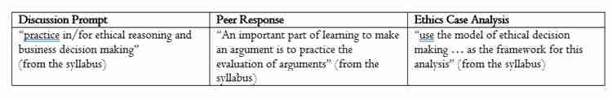
Students receive regular feedback on these assignments from peers and me to help prepare for the final assessment. Through repeated attempts at issue identification and the development of arguments, students should go into the final assessment with a clearer idea of what to expect (i.e., the format of the final assessment will not be novel). Evaluation of the Discussion and Peer Response posts employ a rubric similar to the one used to score the final evaluation (i.e., the framework for evaluation will also be familiar). The key competencies embedded in the rubric (identify ethical issues, apply ethical perspectives, and practice ethical reasoning) guide students throughout the course and across assignments. The rubric also helps students settle expectations, place feedback in context, and practice for the final assessment.

Table 2 illustrates the similar format for these assignments. For this Discussion Prompt (DP) assignment, students must take on the role of a member of the risk management team for a company that makes flushable wipes. For this Ethics Case Analysis (ECA) assignment, students take on the role of the Chief Ethics Officer for a company that makes self-driving cars. In the DP assignment, specific questions guide the work for students. In the ECA prompt, students have more freedom to respond to and operate within the scenario. The questions for the DP are part of the structured practice. The more open-ended scenario of the ECA provides the space for students to demonstrate competency concerning key learning objectives (identify, apply, and practice).

Table 2 Similar Prompts as Practice
In addition to helping students prepare for the final assessment, the DP assignments provide students with regular practice in making connections and mindfully engaging with course materials. Table 3 provides an example.

Table 3 Discussion Prompt/Making Connections
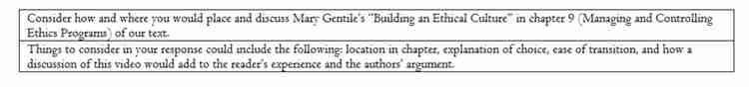
Consider how and where you would place and discuss Mary Gentile’s “Building an Ethical Culture” in chapter 9 (Managing and Controlling Ethics Programs) of our text.
Things to consider in your response could include the following: location in chapter, explanation of choice, ease of transition, and how a discussion of this video would add to the reader’s experience and the authors’ argument.

In this assignment, students exercise agency by selecting portions of assigned course materials to explore and build knowledge by explaining connections among those course materials. Active involvement in creating connections for themselves prepares students for similar work on the final assessment (e.g., identifying ethical issues).

Practice for Failure

When we lower the stakes for assignments and emphasize the role of practice in our courses, we demonstrate to students the importance of failure for learning (Eyler, 2018). Structuring assignments so that students experience them as practice for a final assessment prepares them to see the value of failure. Grading practices that reinforce the importance of failure for learning make it even more likely that students will experience failure as part of learning (Zakrajsek, 2019). For my Business Ethics course, I grade assignments using a best-of format (i.e., dropping the lowest scores after students submit more than the minimum required for the assignment). Here is how I introduce the best-of format for assignments in my syllabus: “The best-of format is designed to provide opportunities for practice, mistakes, reflection, and improvement as part of the overall assessment for the course.” Table 4 provides additional details about what this looks like for students in the course.

Table 4 Best-Of Format for Assignments
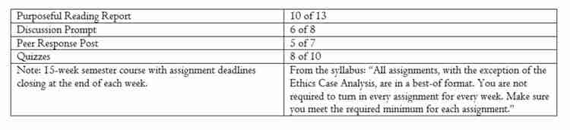
Because practice is not the only design principle relevant for this course, I continue to experiment with the minimum-maximum range to balance the importance of practice with other considerations (e.g., consistent student engagement with course materials throughout the semester). In the end, the specific best-of number is less important than the message sent to students: repeated attempts on similar assignments mean that you can learn because of failure.

Conclusion

The value of formative feedback is recognized in the literature; however, in practice it can be difficult to get student buy in. This post offers suggestions faculty may adopt to increase the chances that students will benefit from feedback attached to a grade. Scaffolded assignments designed for practice (e.g., similar instructions, similar rubrics, and shared learning objectives) and grading practices that support students learning from failure (e.g., best-of format for grading) foreground the context for feedback and invite students to act on the feedback in evaluation.

Discussion Questions

1. Describe a formative assessment used in your course? To what extent does this function as a summative assessment for students? How do you keep formative assessments from becoming summative assessments?

2. How do you provide students with opportunities to practice failure? In doing this, how do you help them to overcome the negative stigma that often accompanies failure?
3. How can you (or how do you) scaffold assignments for students? Select one assignment and describe any current scaffolding with respect to the assignment and how additional scaffolding (or some scaffolding) could be added.

4. Pick one of your courses. What is the most important design principle for that course?

References

Bye, J. K. (2011, May 5). Desirable Difficulties in the Classroom. Psychology Today. Retrieved 3/3/2021 from https://www.psychologytoday.com/us/blog/all-about-addiction/201105/desirable-difficulties-in-the-classroom.

Darby, F. & Lang, J. M. (2019). Small Teaching Online: Applying Learning Science in Online Classes. San Francisco: Jossey-Bass.

Eyler, J.R. (2018). How Humans Learn: The Science and Stories Behind Effective College Teaching. Morgantown: West Virginia University Press.

Fisher, M. R., Jr., & Bandy, J. (2019). Assessing Student Learning. Vanderbilt University Center for Teaching. Retrieved 3/3/2021 from https://cft.vanderbilt.edu/assessing-student-learning/.

Zakrajsek, T. (2019, October 25). Cognitive Load: A Fundamental Key to Student Learning. The Scholarly Teacher. Retrieved 3/3/2021 from https://www.scholarlyteacher.com/post/cognitive-load-a-fundamental-key-to-student-learning.

